**Lab – 6: How to delete a user from Azure AD?**

**Objective:** The objective of this lab is –

* To delete a user from Azure Active Directory.

**Prerequisite:** EMS Enterprise Mobility + Security E5.

**Steps:**

1. Sign in to your Azure Portal, by using the link - **https://portal.azure.com/**. Enter your credentials and click Sign In.

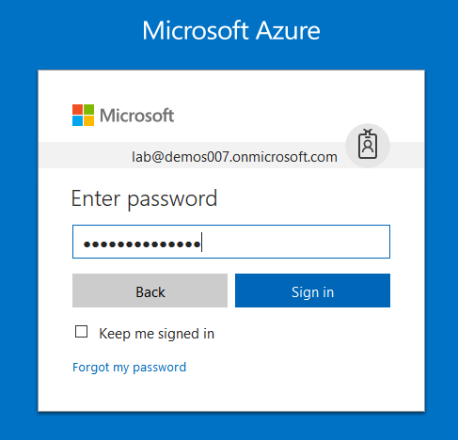

1. Microsoft Azure AD Dashboard will open.

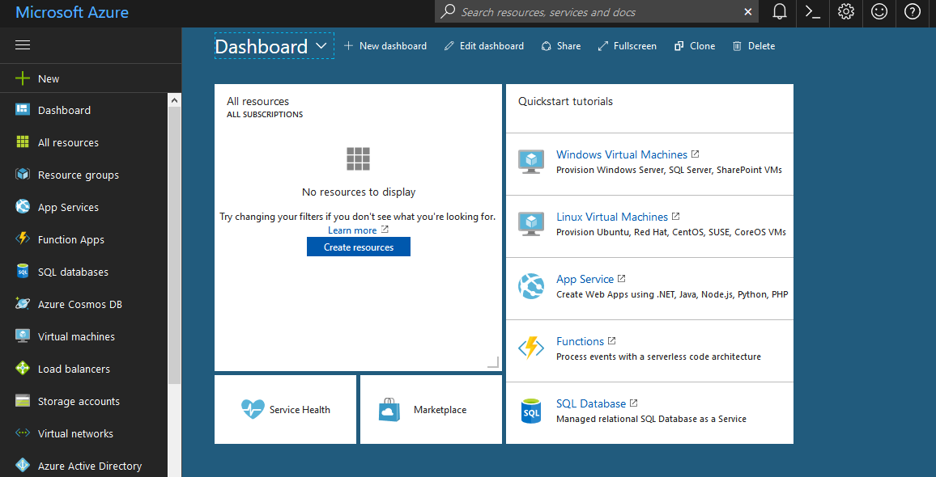

1. Now click **Azure Active Directory** from left-hand pane, and then select **Users and groups**.

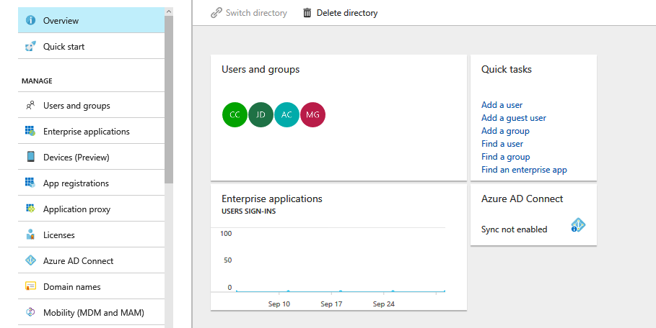

1. On **Users and groups**, select **All users**.

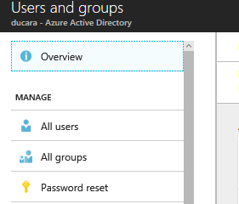

1. And, then select any user to which you want to assign a Password Administrator role in Azure Portal. Here, I am selecting **Jack Daniel**.

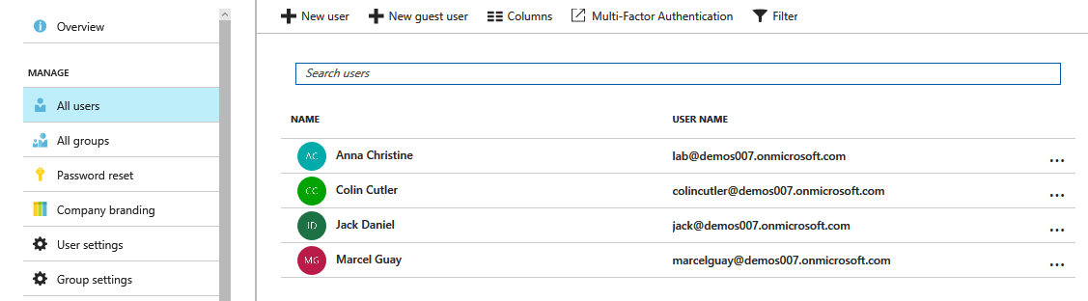

1. User (here, Jack Daniel) profile will open which shows the complete details about that user. On the blade for the selected user, select **Overview**.

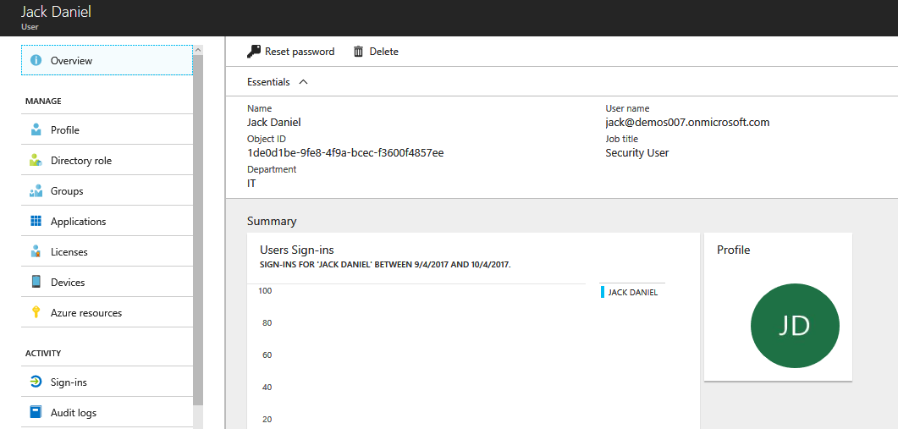

1. And, then in the command bar, select **Delete**.

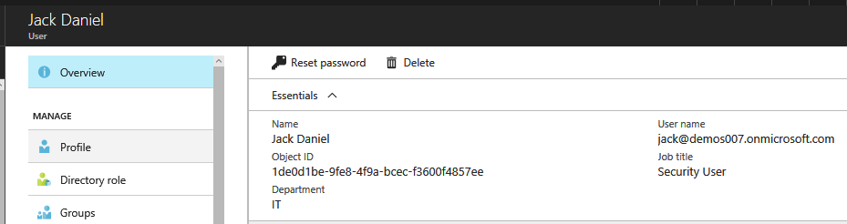

1. So, this is how you can delete a user from Azure Active Directory.